SECTION JE

LUBRICATING OIL RELIEF VALVE

CONTENTS

Chapter

Operation .. .. .. .. .. .. .. .. .. 1

Servicing .. .. .. .. .. .. .. .. .. 2

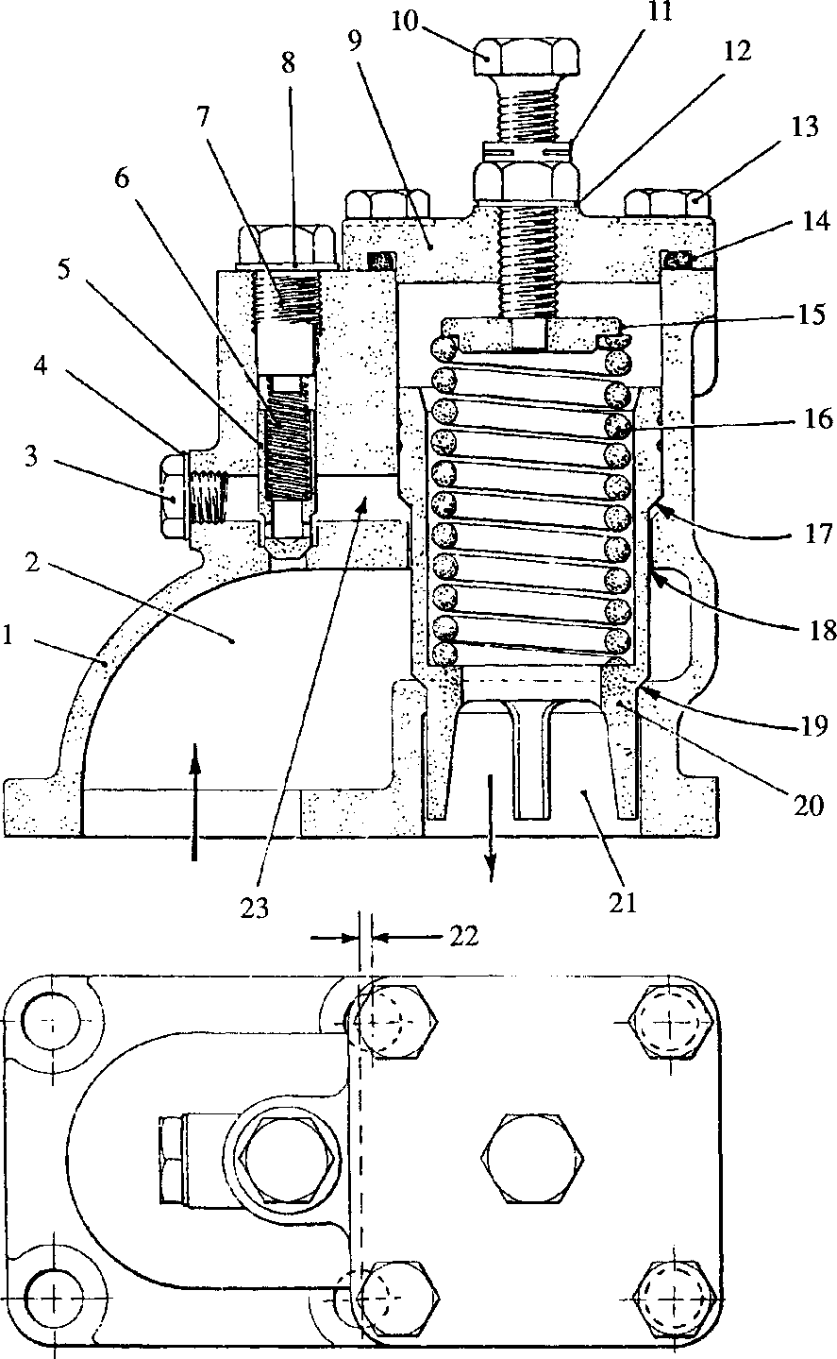

**SPD00343**

Key To Numbers

|  |  |  |  |
| --- | --- | --- | --- |
| 1. | Body | 13. | Setscrew |
| 2. | Inlet port | 14. | 'O' ring |
| 3. | Plug | 15. | Spring carrier |
| 4. | Dowty seal | 16. | Spring |
| 5. | Non-return valve | 17. | Plunger land |
| 6. | Spring | 18. | Plunger clearance |
| 7. | Stop screw | 19. | Plunger land and seat |
| 8. | Dowty seal | 20. | Main relief plunger |
| 9. | Retaining plate | 21. | Relief port |
| 10. | Adjusting screw | 22. | Bolt hole offset |
| 11. | Locknut | 23. | Oil way |
| 12. | Dowty seal |  |  |
|  | Fig JE.l | Lubricating oil | 1 relief valve |

CHAPTER 1

OPERATION

1. The relief valve consists basically of main relief plunger (20) and non-return valve (5) carried in body (1).
2. The main relief plunger is provided with two lands (17) and (19). Oil pressure is required to act on both lands to lift the plunger sufficiently to allow oil to be relieved to drain.
3. Oil entering body (1) via port (2) surrounds main plunger (20) but cannot act on land (19) due to the seating arrangement. The oil lifts non-return valve (5) to enter oilway (23) connecting with land (17). The pressure acting on the land is insufficient to lift the main plunger for relief purposes, but is sufficient to lift land
4. clear of its seating. This allows oil pressure to operate on both lands to lift the plunger against the pressure of spring (16) and allow oil to be relieved to drain via port (21).
5. Immediately the pressure in inlet port (2) and oilway (23) equalise, non-return valve (5) will close to trap the oil in the oilway.
6. Reduction of pressure in inlet port (2) will reduce the effective pressure on the plunger lands and the plunger will close under the influence of spring (16). The rate of closure is controlled by the oil trapped in oilway (23) acting on land (17), the oil bleeding to inlet port (2) via clearance (18), providing a damping action.

CHAPTER 2

SERVICING

Removal and Dismantling

1. Release the six nuts securing relief valve assembly to free-end cover and remove the valve. Remove 'O' rings from free-end cover recesses.
2. Measure and record the distance from adjusting screw boss of retaining plate (9) to the underside of the head of adjusting screw (10).
3. Slacken off locknut (11) and unscrew and remove adjusting screw. Remove dowty seal (12).
4. Release setscrews (13) and remove retaining plate (9). Remove 'O' ring (14).
5. Lift out spring carrier (15), spring (16) and plunger (20) from body (1).
6. Remove stop screw (7) and dowty seal (8). Lift out spring (6) and non-return valve (5).
7. Remove plug (3) and Dowty seal (4).

Inspection

1. Thoroughly wash all components in clean kerosene or fuel oil.
2. Examine body sealing faces for burrs and indentations which may impair sealing.
3. Ensure that main plunger and non-return valve slide smoothly in the body. Check for high spots. Lightly stone any high spots and finally polish with fine emery cloth.
4. Check seatings of main plunger land (19) and non-return valve. If necessary, lightly lap with fine carborundum paste. After lapping, ensure that all traces of grinding paste are washed away.
5. Examine main plunger and non-return valve springs for distortion, collapse and corrosion. The springs, when new should conform to the following measurements:

Main Plunger Spring

Loading when compressed to 16.3 mm (0.64 in) - 43.2 kg ± 2.3 kg (95.25 lb ± 5 lb).

Non-return Valve Spring

Loading when compressed to 16.3 mm (0.64 in) - 1.56 kg ± 0.08 kg (3 lb 7 oz ±3 oz) Check all threaded components for serviceability.

Assembly and Fitting

NOTE All joints and ’O’ rings must be fitted dry.

1. Lubricate main plunger (20) and insert in body. Insert spring (16) and spring carrier
2. .
3. Fit locknut (11) and new dowty seal (12) to adjusting screw (10) and fit to retaining plate (9). Fit new 'O' ring (14) to retaining plate.
4. Place retaining plate in position on valve body, ensuring that the stem of adjusting screw (10) engages with spring carrier (15). Fit and tighten setscrews (13).
5. Set adjusting screw (10) to previously recorded dimension and tighten locknut (11).
6. Insert non-return valve (5) and spring (6) into valve body, and fit and tighten stop screw (7). A new dowty seal (8) should be fitted beneath the stop screw head.
7. Fit plug (3) together with a new dowty seal (4).
8. Fit new 'O' seals to free-end cover recesses, fit valve assembly and secure with philidas nuts.

NOTE The centre securing holes in the body flange are offset to ensure correct replacement.

1. During the first run of the engine, check the pressures correspond to those quoted in Section CB.